**Jenkins Configurations**

AUTHOR: RAMYA

Table of Contents

|  |
| --- |
| 1. Overview………………………………………………………………………………………………………………………… 3 |
| 1. About Jenkins…………………………………………………………………………………………………………………. 3 |
| 1. Jenkins jobs configuration …………………………………………….………………………………………………… 3 |
| |  | | --- | | 3.1 Configured jobs for OAF Migration and Web Service Deployment …………..……………. 3 | | 3.2 steps to run Jenkins job ..…………………………………………………………….…………………. 4 | |
| 1. Conclusion ……………………………………………………………………………………………………………………… 10 |

1. **Overview:**

This Document describes the code migration / webservice deployment using Jenkins.

1. **About Jenkins:**

Jenkins is a powerful application that allows continuous integration and continuous delivery of projects, regardless of the platform you are working on. It is a free source that can handle any kind of build or continuous integration.

1. **Jenkins jobs configuration:**

**3.1. Configured jobs for OAF Migration and Web Service Deployment:**

Jobs configured in Jenkins for SQL/OAF migration.

1. E-Business Suite Extensions - Git deploy- FTP Branch_Master to Upgrade CERT

# E-Business Suite Extensions -Compile plsql objects to CERT

# E-Business Suite Extensions - XML Imports in CERT

Jobs configured in Jenkins for Web service deployment.

# Web Service UnDeploy- CERT

# Web Service Deploy- CERT

**3.2. steps to run Jenkins job:**

1. For webservice deployment we need to follow 4 steps:
   1. Code movement from GITHUB to server.
   2. Check for invalid objects in Database.
   3. Webservice undeploy /deploy.
   4. Give grants.
2. Follow below steps to move the code from GITHUB to server.
   1. Login to Jenkins Url: [**https://cibuild.deere.com/JDF/view/International/**](https://cibuild.deere.com/JDF/view/International/)
   2. go to international -> ebusiness-extensions ->secured-preprod folder.
   3. Search for the first job in the above SQL/OAF migration jobs list (“**E-Business Suite Extensions - Git deploy- FTP Branch_Master to Upgrade CERT**”).
   4. Click on the job. click on build with parameters tab.

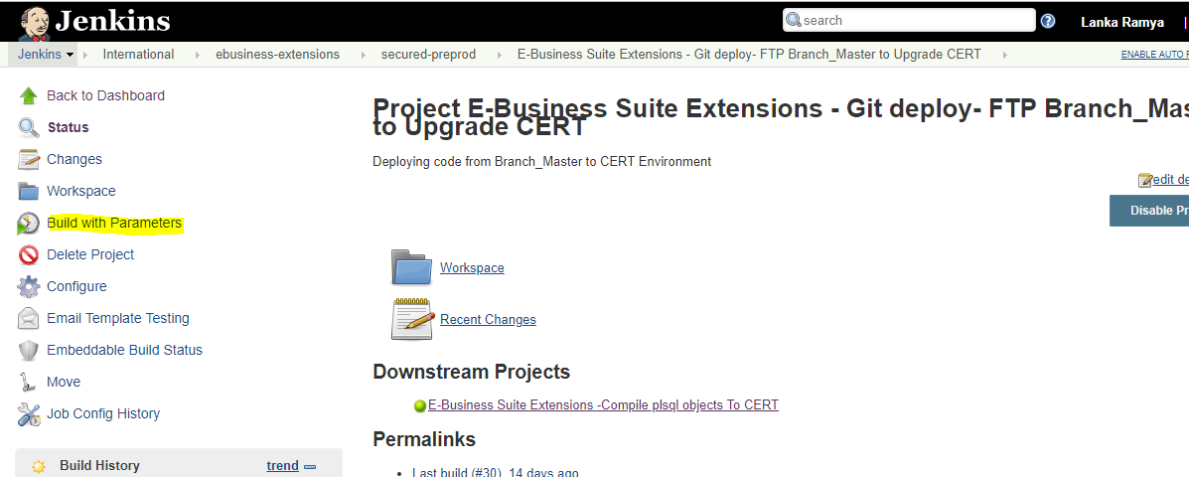

* 1. Provide Apps password and WebLogic password.

**Note: do not pass WebLogic password if downtime(bounce) not needed.**

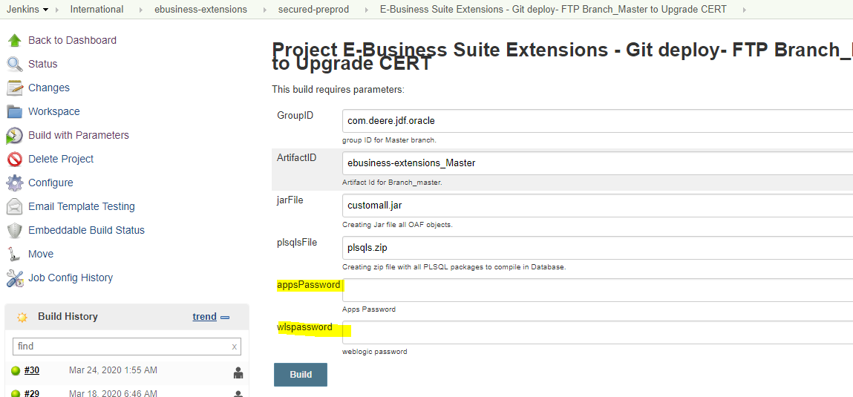

* 1. Click on Build.

1. Check for invalid objects and compile all invalid objects. (make sure all packages are compiled).
2. Run Jenkins job for webservice deployment.
   1. Login to Jenkins [**https://cibuild.deere.com/JDF/view/International/**](https://cibuild.deere.com/JDF/view/International/) **.**
   2. Go to international -> ebusiness-extensions-> webservice deploy folder.

# Open “Web Service UnDeploy- CERT” job to undeploy the existing webservices.

# Click on build with parameters.

# 

# Provide Apps password.

# 

* 1. Click on build.

1. Final step is to apply grants to webservice to access deployed services.
   1. Log in to Oracle E-Business Suite as a user who has the Integration Repository Administrator role. (USER: SYSADMIN)
   2. Select the Integrated SOA Gateway responsibility and the Integration Repository link from the navigation menu.

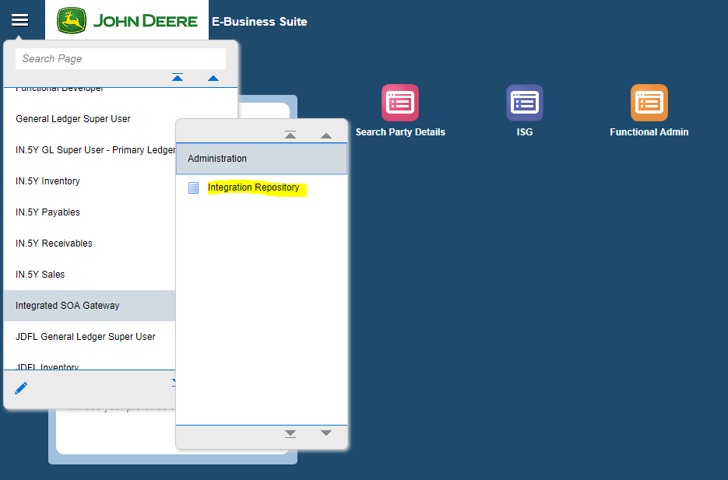

* 1. In the Integration Repository tab, click **Search** to access the main Search page.

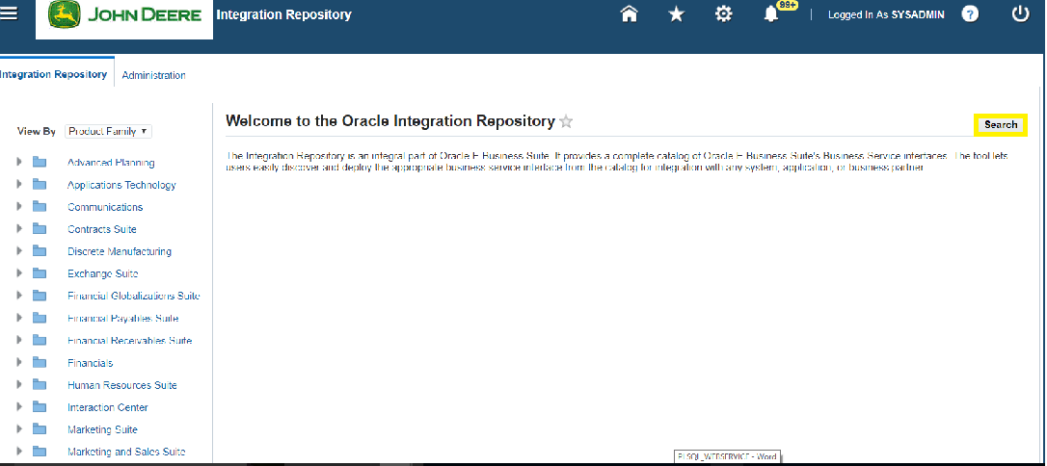

* 1. Enter the internal name (**XXMOBL%**) of the service to fetch the API from list, then click **Go** to execute the search.

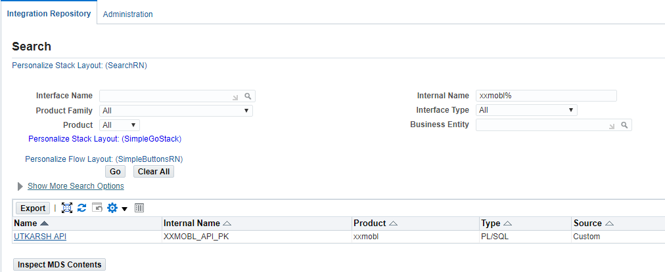

* 1. Click on **UTKARSH API** from search result list.
  2. In the interface details page of the selected custom PLSQL Services, click the Grants tab.
  3. Select the method check box and click on Create Grant.

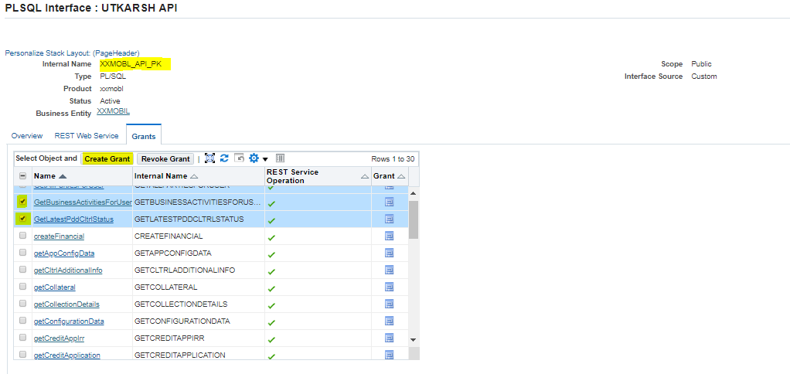

* 1. In the Create Grants page, select "**ASADMIN**" as the Grantee Type.

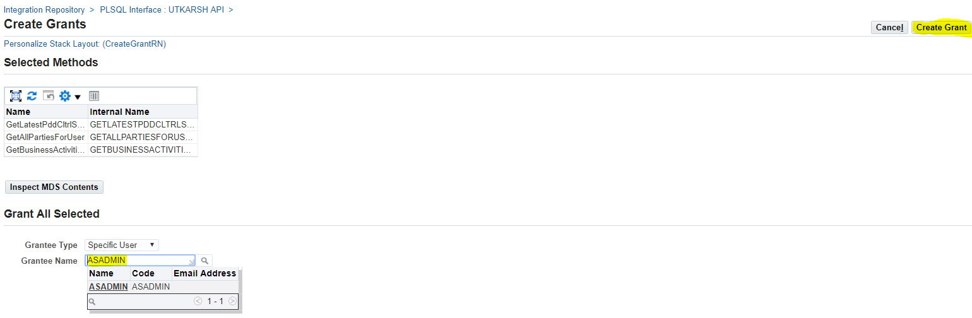

* 1. Click **Create Grant**. This grants the selected method access privilege to ASADMIN user.

1. **Conclusion**

This document gives you an overview of Jenkins jobs related to code movement/webservices deployment.